Pivot Tables

[Insert a Pivot Table](https://www.excel-easy.com/data-analysis/pivot-tables.html#insert-pivot-table) | [Drag fields](https://www.excel-easy.com/data-analysis/pivot-tables.html#drag-fields) | [Sort](https://www.excel-easy.com/data-analysis/pivot-tables.html#sort) | [Filter](https://www.excel-easy.com/data-analysis/pivot-tables.html#filter) | [Change Summary Calculation](https://www.excel-easy.com/data-analysis/pivot-tables.html#change-summary-calculation) | [Two-dimensional Pivot Table](https://www.excel-easy.com/data-analysis/pivot-tables.html#two-dimensional-pivot-table)

Pivot tables are one of Excel's most powerful features. A pivot table allows you to extract the significance from a large, detailed data set.

Our data set consists of 213 records and 6 fields. Order ID, Product, Category, Amount, Date and Country.

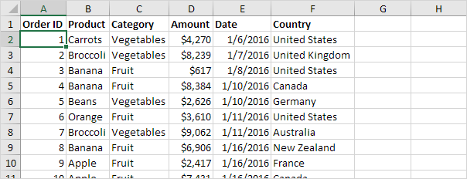

Insert a Pivot Table

To insert a pivot table, execute the following steps.

1. Click any single cell inside the data set.

2. On the Insert tab, in the Tables group, click PivotTable.

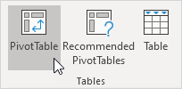

The following dialog box appears. Excel automatically selects the data for you. The default location for a new pivot table is New Worksheet.

3. Click OK.

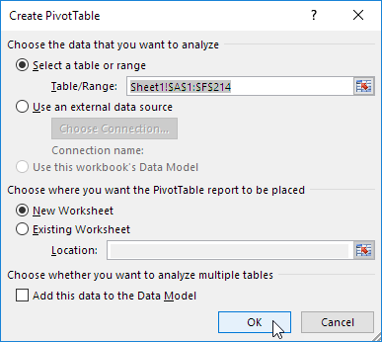

Drag fields

The PivotTable Fields pane appears. To get the total amount exported of each product, drag the following fields to the different areas.

1. Product field to the Rows area.

2. Amount field to the Values area.

3. Country field to the Filters area.

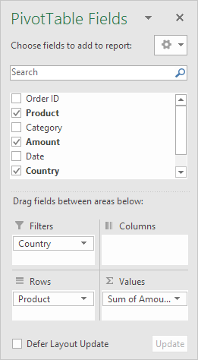

Below you can find the pivot table. Bananas are our main export product. That's how easy pivot tables can be!

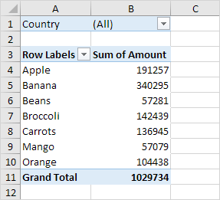

Sort

To get Banana at the top of the list, sort the pivot table.

1. Click any cell inside the Sum of Amount column.

2. Right click and click on Sort, Sort Largest to Smallest.

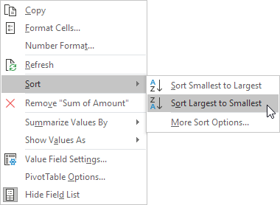

Result.

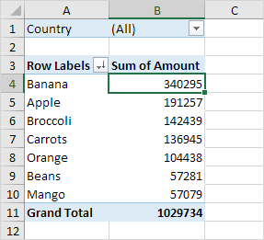

Filter

Because we added the Country field to the Filters area, we can filter this pivot table by Country. For example, which products do we export the most to France?

1. Click the filter drop-down and select France.

Result. Apples are our main export product to France.

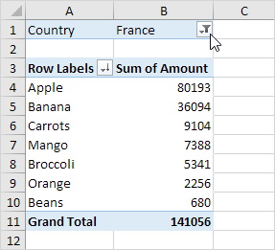

Note: you can use the standard filter (triangle next to Row Labels) to only show the amounts of specific products.

Change Summary Calculation

By default, Excel summarizes your data by either summing or counting the items. To change the type of calculation that you want to use, execute the following steps.

1. Click any cell inside the Sum of Amount column.

2. Right click and click on Value Field Settings.

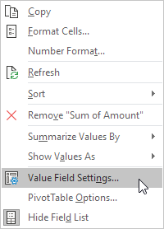

3. Choose the type of calculation you want to use. For example, click Count.

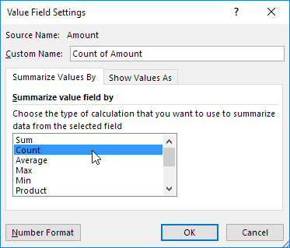

4. Click OK.

Result. 16 out of the 28 orders to France were 'Apple' orders.

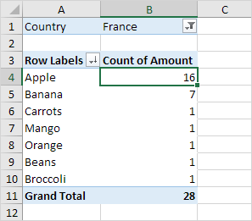

Two-dimensional Pivot Table

If you drag a field to the Rows area and Columns area, you can create a two-dimensional pivot table. First, [insert a pivot table](https://www.excel-easy.com/data-analysis/pivot-tables.html#insert-pivot-table). Next, to get the total amount exported to each country, of each product, drag the following fields to the different areas.

1. Country field to the Rows area.

2. Product field to the Columns area.

3. Amount field to the Values area.

4. Category field to the Filters area.

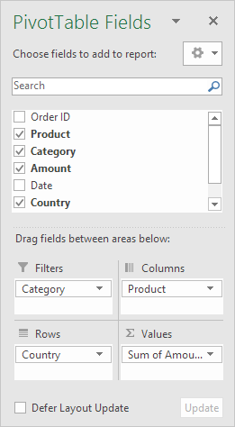

Below you can find the two-dimensional pivot table.

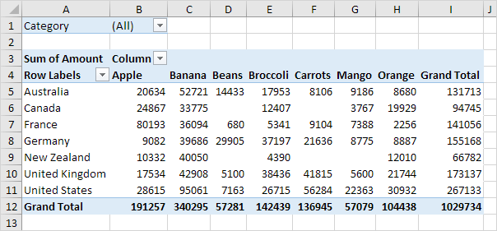

To easily compare these numbers, create a [pivot chart](https://www.excel-easy.com/examples/pivot-chart.html) and apply a filter. Maybe this is one step too far for you at this stage, but it shows you one of the many other powerful pivot table features Excel has to offer.

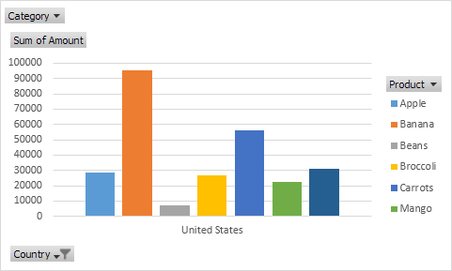

Group Pivot Table Items

[Group Products](https://www.excel-easy.com/examples/group-pivot-table-items.html#group-products) | [Group Dates](https://www.excel-easy.com/examples/group-pivot-table-items.html#group-dates)

This example teaches you how to group pivot table items. Learn how to group products and how to group dates by quarters.

Below you can find a pivot table. Go back to [Pivot Tables](https://www.excel-easy.com/data-analysis/pivot-tables.html) to learn how to create this pivot table.



Group Products

The Product field contains 7 items. Apple, Banana, Beans, Broccoli, Carrots, Mango and Orange.

To create two groups, execute the following steps.

1. In the pivot table, select Apple and Banana.

2. Right click and click on Group.

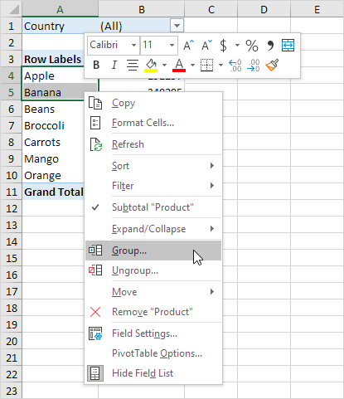

3. In the pivot table, select Beans, Broccoli, Carrots, Mango and Orange.

4. Right click and click on Group.

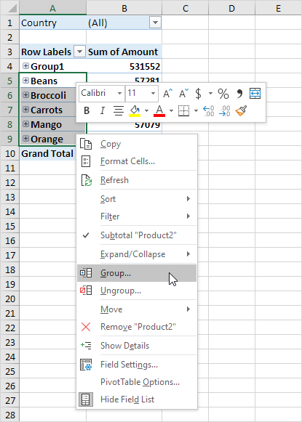

Result:

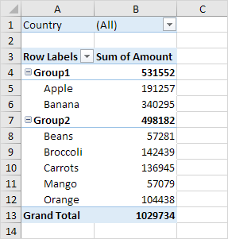

Note: to change the name of a group (Group1 or Group2), select the name, and edit the name in the formula bar. To ungroup, select the group, right click and click on Ungroup.

5. To collapse the groups, click the minus signs.

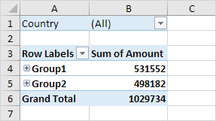

Conclusion: Apple and Banana (Group1) have a higher total than all the other products (Group2) together.

Group Dates

To create the pivot table below, instead of the Product field, add the Date field to the Rows area. The Date field contains many items. 6-Jan, 7-Jan, 8-Jan, 10-Jan, 11-Jan, etc.

To group these dates by quarters, execute the following steps.

1. Click any cell inside the column with dates.

2. Right click and click on Group.

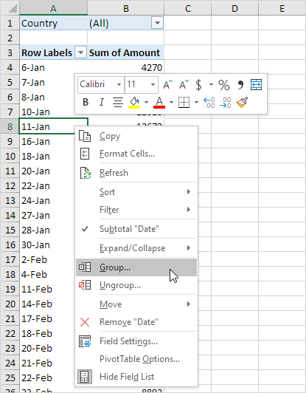

3. Select Quarters and click OK.

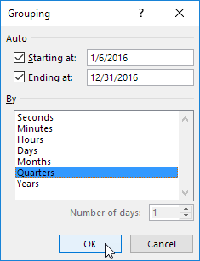

Note: also see the options to group by seconds, minutes, hours, etc.

Result:

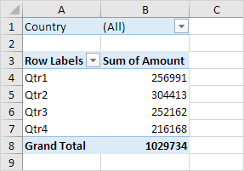

Conclusion: Quarter 2 is the best quarter.

Multi-level Pivot Table

[Multiple Row Fields](https://www.excel-easy.com/examples/multi-level-pivot-table.html#multiple-row-fields) | [Multiple Value Fields](https://www.excel-easy.com/examples/multi-level-pivot-table.html#multiple-value-fields) | [Multiple Report Filter Fields](https://www.excel-easy.com/examples/multi-level-pivot-table.html#multiple-report-filter-fields)

It's perfectly ok to drag more than one field to an area in a pivot table. We will look at an example of multiple row fields, multiple value fields and multiple report filter fields.

Remember, our data set consists of 213 records and 6 fields. Order ID, Product, Category, Amount, Date and Country.



Multiple Row Fields

First, [insert a pivot table](https://www.excel-easy.com/data-analysis/pivot-tables.html#insert-pivot-table). Next, drag the following fields to the different areas.

1. Category field and Country field to the Rows area.

2. Amount field to the Values area.

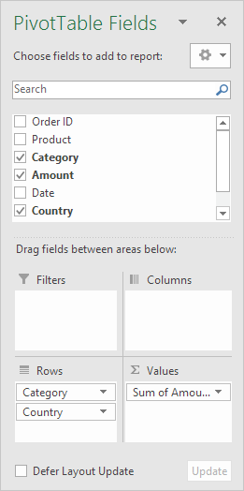

Below you can find the multi-level pivot table.

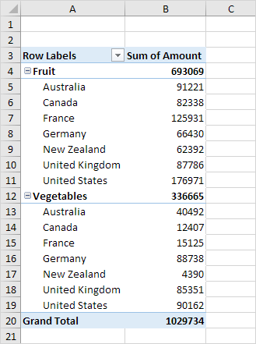

Multiple Value Fields

First, [insert a pivot table](https://www.excel-easy.com/data-analysis/pivot-tables.html#insert-pivot-table). Next, drag the following fields to the different areas.

1. Country field to the Rows area.

2. Amount field to the Values area (2x).

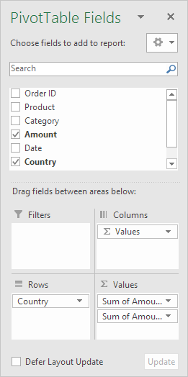

Note: if you drag the Amount field to the Values area for the second time, Excel also populates the Columns area.

Pivot table:

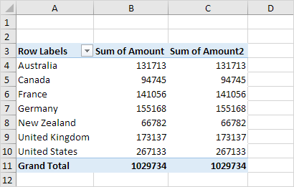

3. Next, click any cell inside the Sum of Amount2 column.

4. Right click and click on Value Field Settings.

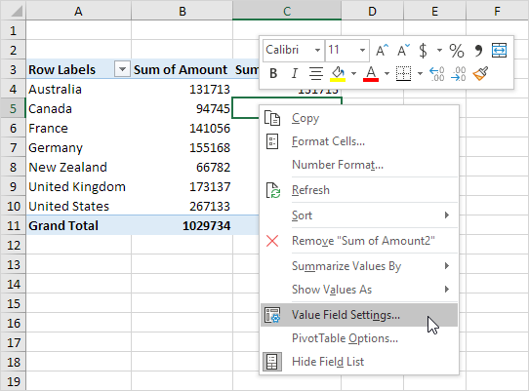

5. Enter Percentage for Custom Name.

6. On the Show Values As tab, select % of Grand Total.

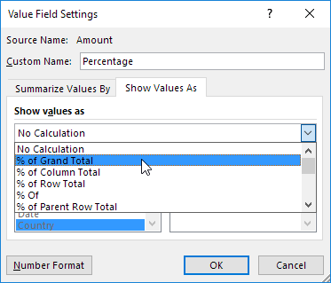

7. Click OK.

Result:

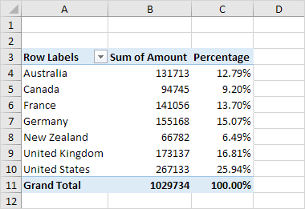

Multiple Report Filter Fields

First, [insert a pivot table](https://www.excel-easy.com/data-analysis/pivot-tables.html#insert-pivot-table). Next, drag the following fields to the different areas.

1. Order ID to the Rows area.

2. Amount field to the Values area.

3. Country field and Product field to the Filters area.

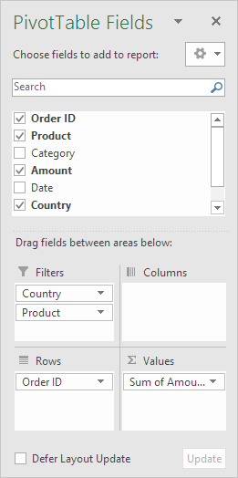

4. Next, select United Kingdom from the first filter drop-down and Broccoli from the second filter drop-down.

The pivot table shows all the 'Broccoli' orders to the United Kingdom.

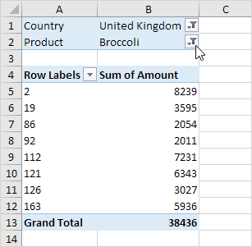

Frequency Distribution

Did you know that you can use pivot tables to easily create a frequency distribution in Excel? You can also use the Analysis Toolpak to create a [histogram](https://www.excel-easy.com/examples/histogram.html).

Remember, our data set consists of 213 records and 6 fields. Order ID, Product, Category, Amount, Date and Country.



First, [insert a pivot table](https://www.excel-easy.com/data-analysis/pivot-tables.html#insert-pivot-table). Next, drag the following fields to the different areas.

1. Amount field to the Rows area.

2. Amount field (or any other field) to the Values area.

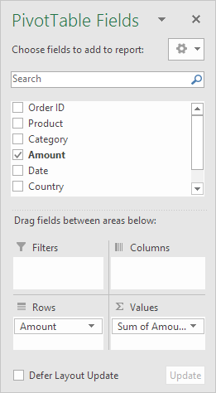

3. Click any cell inside the Sum of Amount column.

4. Right click and click on Value Field Settings.

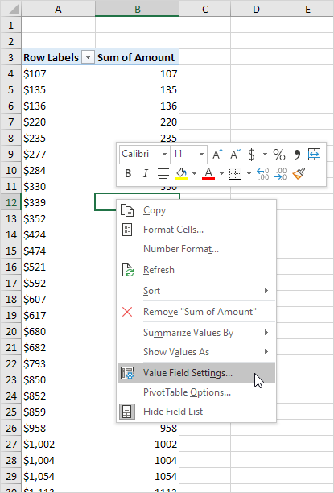

5. Choose Count and click OK.

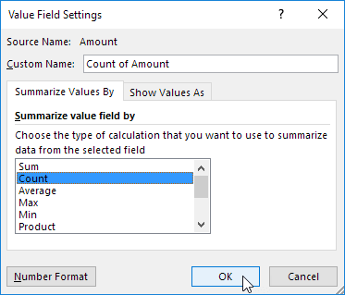

6. Next, click any cell inside the column with Row Labels.

7. Right click and click on Group.

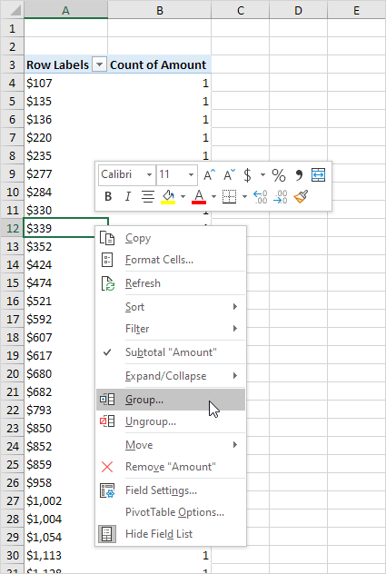

8. Enter 1 for Starting at, 10000 for Ending at, and 1000 for By.

9. Click OK.

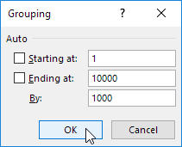

Result:

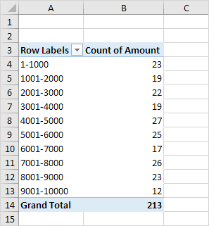

To easily compare these numbers, create a pivot chart.

10. Click any cell inside the pivot table.

11. On the Analyze tab, in the Tools group, click PivotChart.

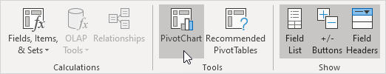

The Insert Chart dialog box appears.

12. Click OK.

Result:

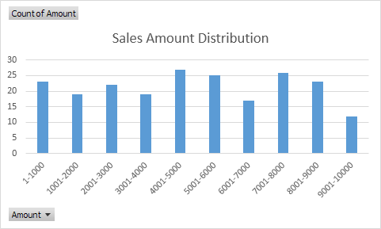

Pivot Chart

[Insert Pivot Chart](https://www.excel-easy.com/examples/pivot-chart.html#insert-pivot-chart) | [Filter Pivot Chart](https://www.excel-easy.com/examples/pivot-chart.html#filter-pivot-chart) | [Change Pivot Chart Type](https://www.excel-easy.com/examples/pivot-chart.html#change-pivot-chart-type)

A pivot chart is the visual representation of a pivot table in Excel. Pivot charts and pivot tables are connected with each other.

Below you can find a two-dimensional pivot table. Go back to [Pivot Tables](https://www.excel-easy.com/data-analysis/pivot-tables.html#two-dimensional-pivot-table) to learn how to create this pivot table.



Insert Pivot Chart

To insert a pivot chart, execute the following steps.

1. Click any cell inside the pivot table.

2. On the Analyze tab, in the Tools group, click PivotChart.

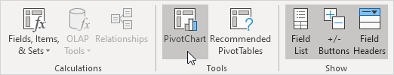

The Insert Chart dialog box appears.

3. Click OK.

Below you can find the pivot chart. This pivot chart will amaze and impress your boss.

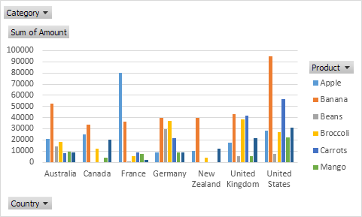

Note: any changes you make to the pivot chart are immediately reflected in the pivot table and vice versa.

Filter Pivot Chart

To filter this pivot chart, execute the following steps.

1. Use the standard filters (triangles next to Product and Country). For example, use the Country filter to only show the total amount of each product exported to the United States.



2. Remove the Country filter.

3. Because we added the Category field to the Filters area, we can filter this pivot chart (and pivot table) by Category. For example, use the Category filter to only show the vegetables exported to each country.

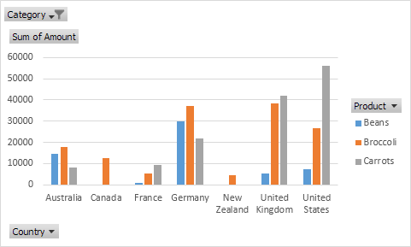

Change Pivot Chart Type

You can change to a different type of pivot chart at any time.

1. Select the chart.

2. On the Design tab, in the Type group, click Change Chart Type.

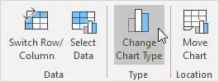

3. Choose Pie.

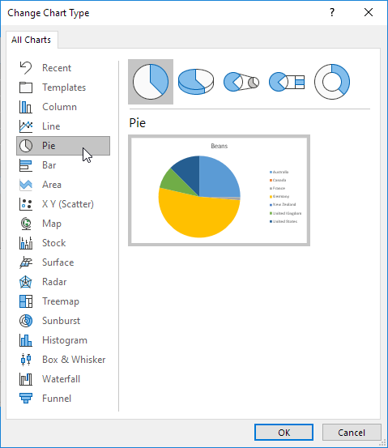

4. Click OK.

Result:

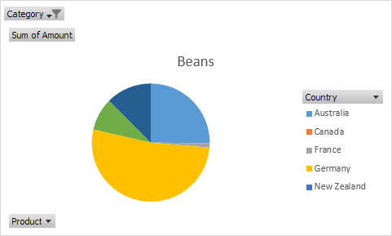

Note: pie charts always use one data series (in this case, Beans). To get a pivot chart of a country, swap the data over the axis. First, select the chart. Next, on the Design tab, in the Data group, click Switch Row/Column.

Slicers

You can insert slicers in Excel to quickly and easily filter pivot tables. However, using the report filter gives the exact same result.

Below you can find a two-dimensional pivot table. Go back to [Pivot Tables](https://www.excel-easy.com/data-analysis/pivot-tables.html#two-dimensional-pivot-table) to learn how to create this pivot table.



To insert a slicer, execute the following steps.

1. Click any cell inside the pivot table.

2. On the Analyze tab, in the Filter group, click Insert Slicer.

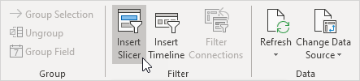

3. Check Category and click OK.

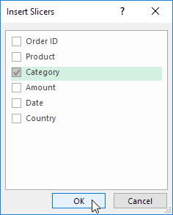

4. For example, click Fruit to only show the fruit exported to each country.

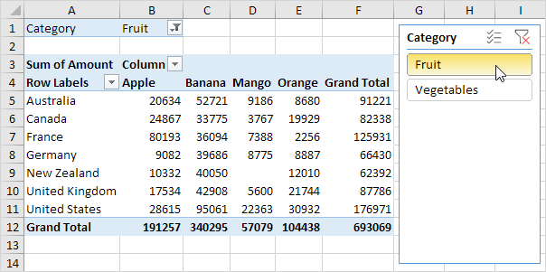

Note: the report filter (cell B1) changes to Fruit. Hold down CTRL to include fruit and vegetables.

Update Pivot Table

[Refresh](https://www.excel-easy.com/examples/update-pivot-table.html#refresh) | [Change Data Source](https://www.excel-easy.com/examples/update-pivot-table.html#change-data-source)

Any changes you make to the data set are not automatically picked up by the pivot table. Refresh the pivot table or change the data source to update the pivot table with the applied changes.

Refresh

If you change any of the text or numbers in your data set, you need to refresh the pivot table.

1. Click any cell inside the pivot table.

2. Right click and click on Refresh.

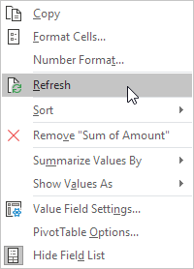

Change Data Source

If you change the size of your data set by adding or deleting rows/columns, you need to update the source data for the pivot table.

1. Click any cell inside the pivot table.

2. On the Analyze tab, in the Data group, click Change Data Source.

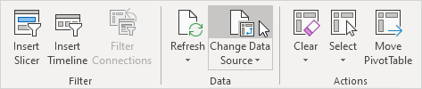

Tip: change your data set to a [table](https://www.excel-easy.com/data-analysis/tables.html) before you insert a pivot table. This way your data source will be updated automatically when you add or delete rows/columns. This can save time. You still have to refresh though.

Calculated Field/Item

[Calculated Field](https://www.excel-easy.com/examples/calculated-field-item.html#calculated-field) | [Calculated Item](https://www.excel-easy.com/examples/calculated-field-item.html#calculated-item)

This example teaches you how to insert a calculated field or calculated item in a pivot table.

Below you can find a pivot table. Go back to [Pivot Tables](https://www.excel-easy.com/data-analysis/pivot-tables.html) to learn how to create this pivot table.

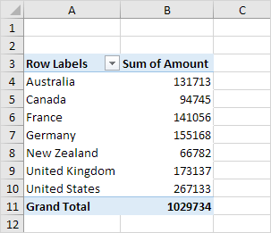

Calculated Field

A calculated field uses the values from another field. To insert a calculated field, execute the following steps.

1. Click any cell inside the pivot table.

2. On the Analyze tab, in the Calculations group, click Fields, Items & Sets.

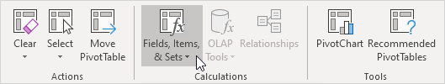

3. Click Calculated Field.

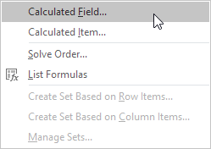

The Insert Calculated Field dialog box appears.

4. Enter Tax for Name.

5. Type the formula =IF(Amount>100000, 3%*Amount, 0)

6. Click Add.

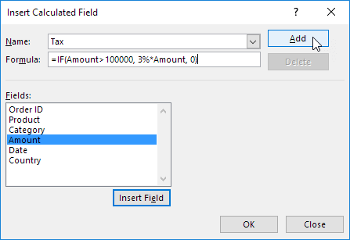

Note: use the Insert Field button to quickly insert fields when you type a formula. To delete a calculated field, select the field and click Delete (under Add).

7. Click OK.

Excel automatically adds the Tax field to the Values area.

Result:

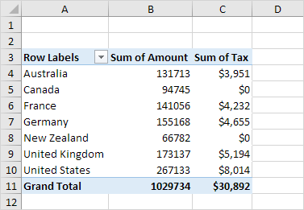

Calculated Item

A calculated item uses the values from other items. To insert a calculated item, execute the following steps.

1. Click any Country in the pivot table.

2. On the Analyze tab, in the Calculations group, click Fields, Items & Sets.



3. Click Calculated Item.

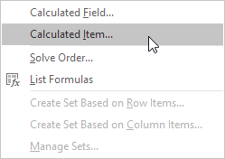

The Insert Calculated Item dialog box appears.

4. Enter Oceania for Name.

5. Type the formula =3%*(Australia+'New Zealand')

6. Click Add.

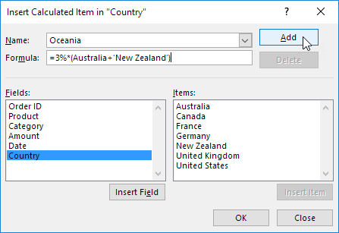

Note: use the Insert Item button to quickly insert items when you type a formula. To delete a calculated item, select the item and click Delete (under Add).

7. Repeat steps 4 to 6 for North America (Canada and United States) and Europe (France, Germany and United Kingdom) with a 4% and 5% tax rate respectively.

8. Click OK.

Result:

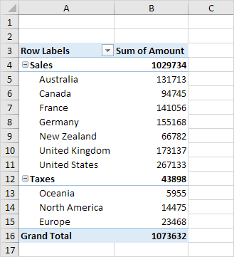

Note: we created two [groups](https://www.excel-easy.com/examples/group-pivot-table-items.html) (Sales and Taxes).

GetPivotData

To quickly enter a GETPIVOTDATA function in Excel, type an equal sign (=) and click a cell in a [pivot table](https://www.excel-easy.com/data-analysis/pivot-tables.html). The GETPIVOTDATA function can be quite useful.

1. First, select cell B14 below and type =D7 (without clicking cell D7 in the pivot table) to reference the amount of beans exported to France.

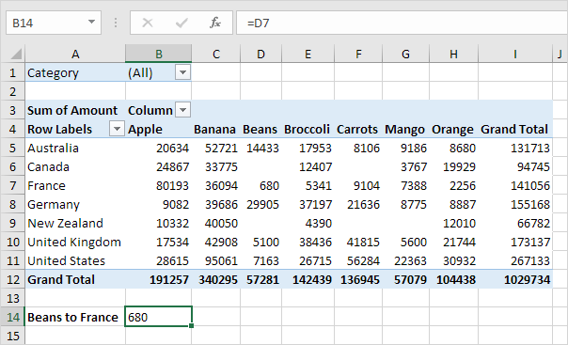

2. Use the filter to only show the amounts of vegetables exported to each country.

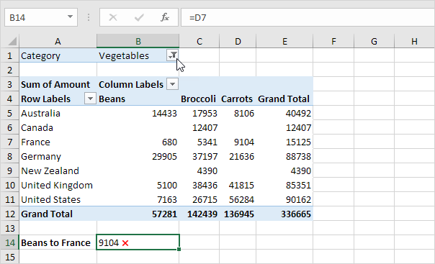

Note: cell B14 now references the amount of carrots exported to France, not the amount of beans. GETPIVOTDATA to the rescue!

3. Remove the filter. Select cell B14 again, type an equal sign (=) and click cell D7 in the pivot table.

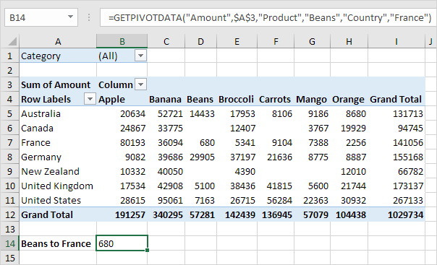

Note: Excel automatically inserts the GETPIVOTDATA function shown above.

4. Again, use the filter to only show the amounts of vegetables exported to each country.

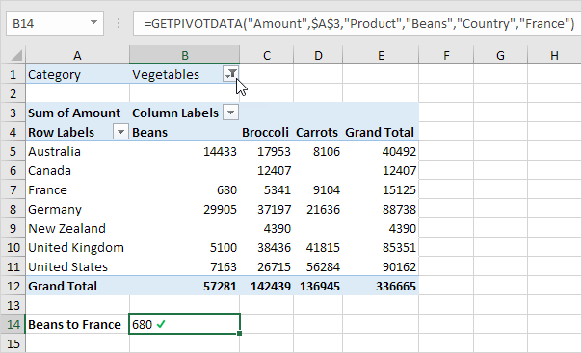

Note: the GETPIVOTDATA function correctly returns the amount of beans exported to France.

5. The GETPIVOTDATA function can only return data that is visible. For example, use the filter to only show the amounts of fruit exported to each country.

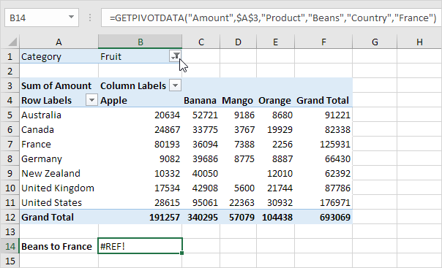

Note: the GETPIVOTDATA function returns a #REF! error because the value 680 (beans to France) is not visible.

6. The dynamic GETPIVOTDATA function below returns the amount of mango exported to Canada.

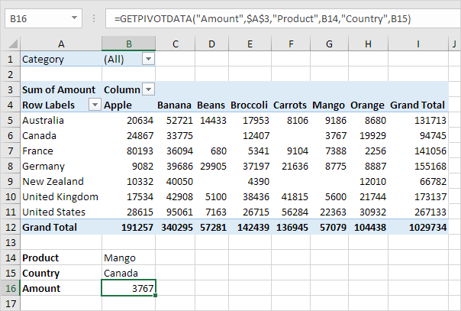

Note: this GETPIVOTDATA function has 6 arguments (data field, a reference to any cell inside the pivot table and 2 field/item pairs). Create a [drop-down list](https://www.excel-easy.com/examples/drop-down-list.html) in cell B14 and cell B15 to quickly select the first and second item (see downloadable Excel file).

7. The GETPIVOTDATA function below has 4 arguments (data field, a reference to any cell inside the pivot table and 1 field/item pair) and returns the total amount exported to the USA.

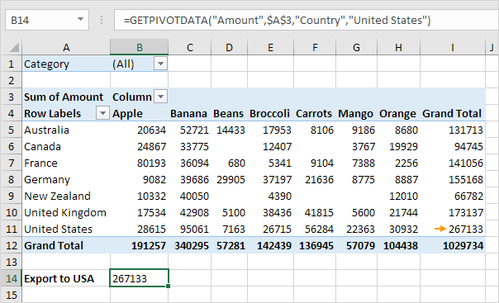

8. If the total amount exported to the USA changes (for example, by using a filter), the value returned by the GETPIVOTDATA function also changes.

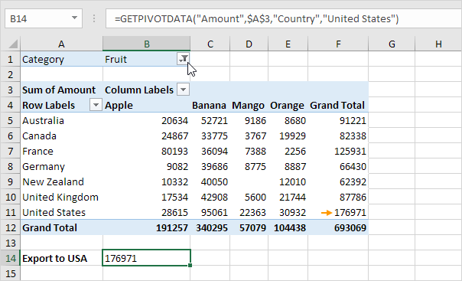

If you don't want Excel to automatically insert a GETPIVOTDATA function, you can turn off this feature.

9. Click any cell inside the pivot table.

10. On the Analyze tab, in the PivotTable group, click the drop-down arrow next to Options and uncheck Generate GetPivotData.

